Q#1 | Find spanning tree by the method of the proof of the corollary for each of the following graphs.  Corollary: Every connected graph has a spanning tree.  (a)  (b)  (c)  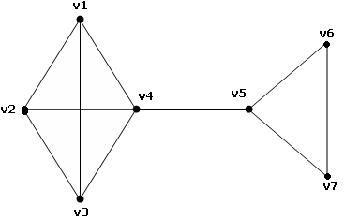
   | v₁ | v₂ | v₃ | v₄
  v₂ | 0
  v₃ | 1 | 1
  v₄ | 1 | 1 | 1
  v₅ | 1 | 1 | 0 | 1
   | v₁ | v₂ | v₃ | v₄ | v₅
  v₂ | 1
  v₃ | 1 | 1
  v₄ | 1 | 1 | 0
  v₅ | 1 | 1 | 1 | 1
  v₆ | 0 | 1 | 1 | 1 | 1
Q#2 | Prove that exactly ρ(g) edges must be removed from the graph G to obtain a spanning tree.
Q#3 | For the graphs in Q#1, find the maximal independent collection of circuits.  Note: First find the spanning forest, and then perform the computation.
Q#4 | Prove that the following statements are equivalent by using the implication  (i) → (ii) → (iii)  - G is acyclic and has n-1 edges  - Every pair of vertices in G is joined by exactly one path.  - G is edge minimal with respect to being connected.
Q#5 | Find the minimal-cost spanning tree from the following graph.  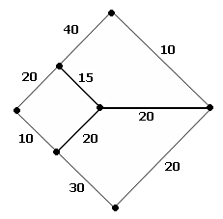
Q#6 | Show by using invariants that the following graphs are isomorphic or not.  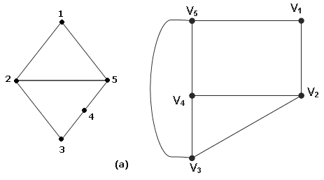  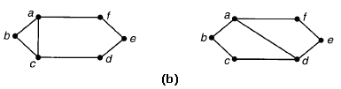
Q#7 | Show that the pairs of graphs are isomorphic, by finding an isomorphism from one graph to the other.  